Ravan Muradzada
It has created a new user named `mr-ravan` here.

- 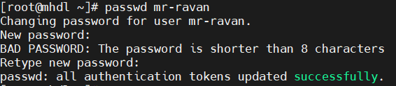
I have set password here for new user.

It switches to another user.

- 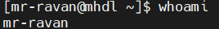
`whoami` gives our username. We have switched to another user, so our username is changed, too.

- 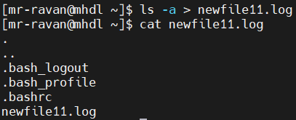
`ls -a` shows all files including hidden ones. `>` redirects the output to specified fle.

- 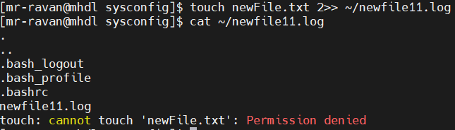
I used `2>>`, because I want to append (not overwrite) std err to specified file. In this directory for normal users, creating a new file is denied, thus error occurred and I have redirected this error to our log file.

`&>>` helps us to redirect both std out and std err to the same file. (It is appending, not overwriting).

- 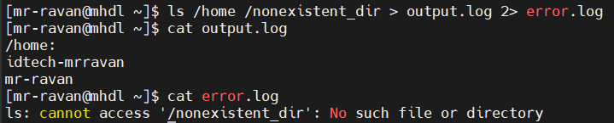

- > - Ovewrites std output.
- >> - Appends std output without overwriting.
- 1> - Same with >
- 1>> - Same with >>
- 2> - Overwrites std err.
- 2>> - Appends std err without overwriting.
- > 2>&1 (or just &>) - Overwrites both std out and std err to the same file.
- >> 2>&1 (or just &>>) - Appends both std out and std err to the same file.
- > /dev/null - Sends any std out result to null, discards and does not save anywhere.
- 2> 1.log 1> 2.log - This overwrites std out to 2.log, std.err to 1.log.
- | (pipe) – It takes the output of the first command and gives it to the second command as an input

- $ is actually a special character and used to represent variables itself. Its usage inside string can confuse the system. We should use single quotes, because single quotes think everything inside as a string.
- Using `!` multiple times (like `!!`, `!!!`) can trigger history expansion, causing Bash to try replacing it with previous commands, which may lead to unexpected results or errors.
- “ “ (double quotes) - Allow variable expansion and command substitution.
‘ ‘ (single quotes) - Everything inside them is taken literally. No variable expansion, no command substitution, no special character meaning.
` ` (backlist) – Used for command substitution. They execute a command and replace it with its output. (Example: echo `pwd`)
- Double quotes can contain variable expansions like if we have a variable of x=5, we can express it in a string like echo “My variable is $x”. The result will be “My variable is 5”.
However, for single quote there is no variable expansion. Even if we have a variable of x=5 and we write echo ‘My variable is $x’, the result will be just “My variable is $x”.
- It is used to represent an output of any command. Example: echo `ls`. As a result, it will run ls command. Moreover, it can be used inside files which contain runnable commands. If other quotes are used instead, the command will not be run.

